Final Project Report
1. Introduction
1.1. Project overviews
This project focuses on agricultural crop production trends from 1997 to 2021 across India, states-wise production distribution with maps, season-wise agricultural production share, identification
of states with high and low production, identification of high performing crops and an interactive
1.2. Objectives: -
dashboard for all visualizations.
• To understand India’s agricultural crop production.To identify regions with low and high crop yields.To understand long term production trends.To evaluate the impact of seasonal variations
2. Project Initialization and Planning Phase
2.1. Define Problem Statement
Problem I am But Because Which makes me feel
 |  | I’mtrying to
1 |  | Government There is no Challenging to make
 |  | Policy Analyst | agricultural productivity across  India. |  | It is difficult to understand hidden patterns of crops across India. | single visual platform that shows  productivity pattern of crops. | effective policies for farmers to increase productivity.
2 |  | Small-Scale Farmer | Maximize crop yield and income |  | It is difficult to find out which crop has high yield and high demand during a season | There is no single visual platform that shows crop yield and demand during seasons. | Challenging to make a decision which crop I should grow to maximize yield and Income.

2.2. Project Proposal (Proposed Solution)

Project Overview
Objective | ❖To understand India’s agricultural crop production.  • To identify regions with low and high crop yields.  • To understand long term production trends.  • To evaluate the impact of seasonal variations.
Scope | Analysis of crop production from 1997 to 2021.

Problem Statement
DescriptionThere is no single visual There is no single visual crop | to show seasonal and yearly trends in  production, cultivated area for different crops, regions with high and  low production, comparison of cultivated areas among different
ImpactThis visualization will This visualization will policies | crops.  help policymakers to develop effective  to increase agricultural productivity, allocate resources effectively  and help farmers to make informed about crop selection based on
Proposed Solution farming
ApproacCollect the data from Collect the data from India | 1997 to 2021 on crop production across  from the ministry of agriculture and other agriculture related
Key FeaturesAgriculture production Agriculture production states- | websites.  trends from 1997 to 2021 across India,  wise production distribution with maps, season-wise agricultural production share, identification of states with high and low production, identification of high performing crops and an interactive

dashboard for all visualizations.

Resource Requirements
Resource Type | Description | Specification/Allocation
Hardware
CPU/GPU specifications, number Computing Resources
2 x NVIDIA V100 GPUs of cores
Memory | RAM specifications 8 | GB
Disk space for data, models, and Storage
512GB SSD logs
Software
Frameworks | Python frameworks | Flask
Libraries | Additional libraries | scikit-learn, pandas, numpy

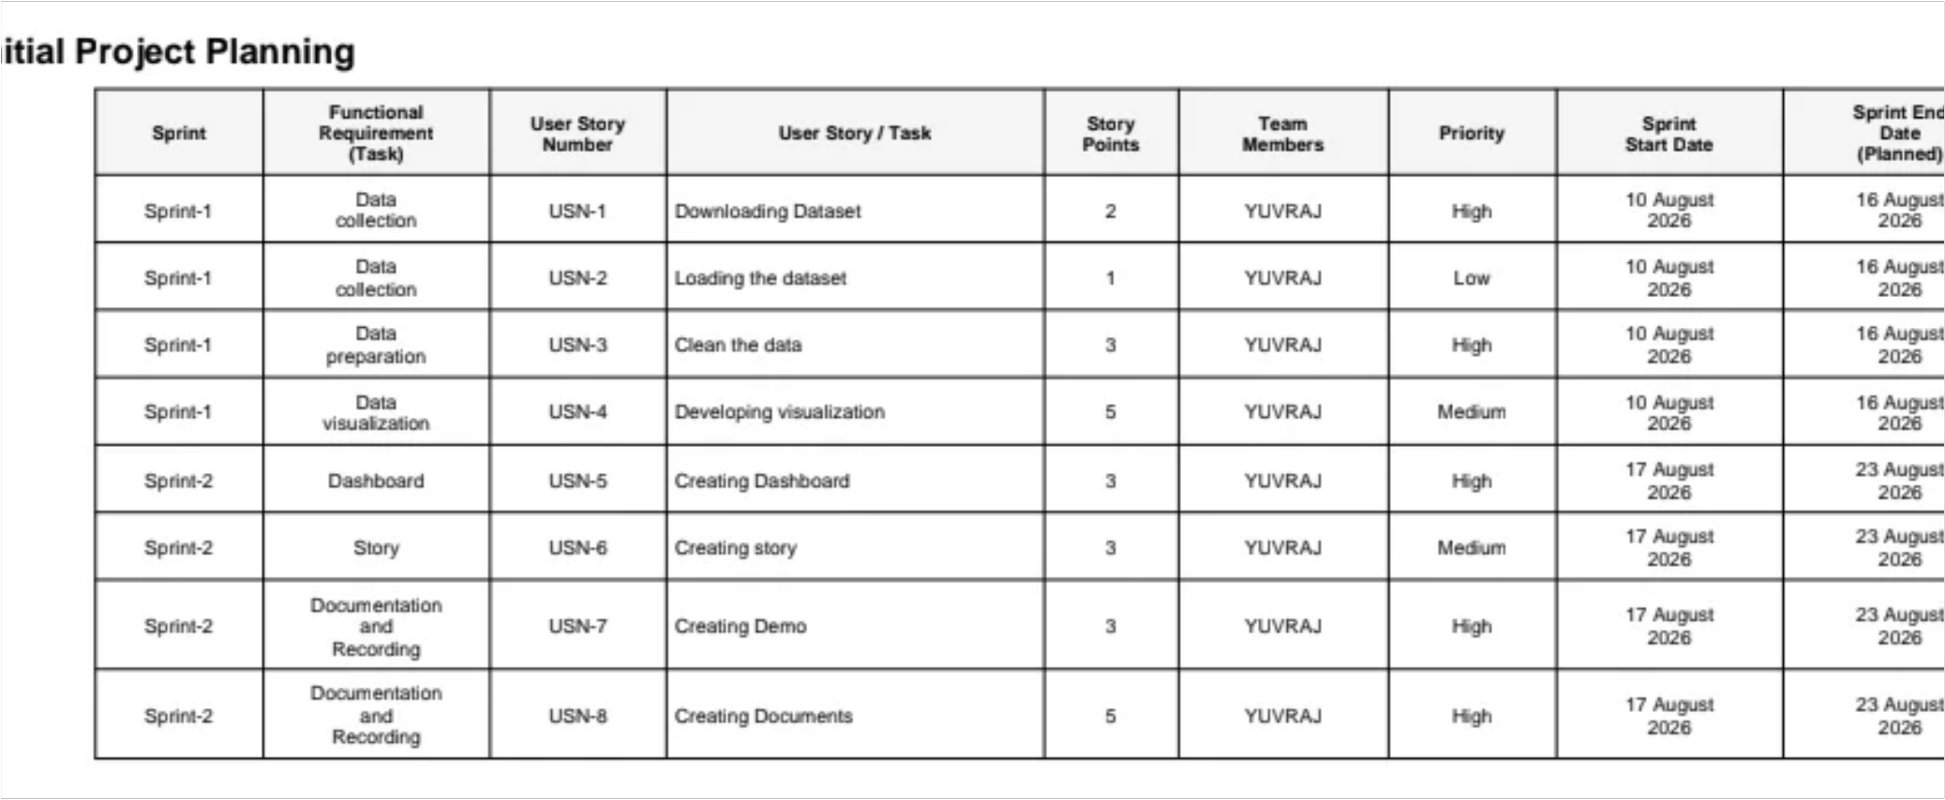
Development Environment | IDE, version control | Jupyter Notebook, Git
Data
Data | Source | Ministry of Agriculture and Farmers Welfare ,Directorate of  Economics and Statistics, Smart

bridge site ,UPAg Portal
2.3. Initial Project Planning

3. Data Collection and Preprocessing Phase
3.1. Data Collection Plan and Raw Data Sources Identified
Section | Description
Project Overview
increase production

Data Collection Plan | Dataset is collected from agriculture department of India, Smart  bridge site, UPAg Portal and Directorate of Economics and Statistics.
Raw Data Sources Identified | Ministry of Agriculture and Farmers Welfare  Directorate of Economics and Statistics  Smart bridge site UPAg Portal
Raw Data Sources
Source  Name | Description | Location/URL | Format | Size | Access Permissions
Ministry of Agriculture and
https://agriwelfare
Dataset 1 Farmers Welfare .gov.in/en/StatHo CSV 1GB Public
rtEst
Dataset 2 | Directorate of Economics and Statistics | https://data.desagr i.gov.in/website/c rops-apy-report- web | Excel | 1GB | Public
Smart bridge site
https://thesmartbri
Dataset 3 Excel 1 GB Public
dge.com/

3.2. Data Quality Report

Data  Data Quality Issue  Source |  | Severity | Resolution Plan
Dataset 1 Some missing numbers. Moderate Filter the data and add missing
numbers
Reports related to agriculture
Make a single excel file
Dataset 2 production for each crop are High
containing all reports.
separated.

Some values of dataset are  Dataset 3  different from other dataset |  | medium | Compare with other dataset and find authentic data from official websites.
3.3. Data Ex ploration and Preprocessing
Section | Description
Data Overview | Dataset is related to India’s agriculture crop production from 1997 to 2021.
Execute data cleaning workflows Data Cleaning  deduplicate records, and rectify | to impute missing entries, data anomalies
Data manipulation: filtering, Data Transformation calculated columns. | sorting, pivoting, and creating
Data Type Conversion | Rectifying Datatype
Column Splitting and  Split or merge columns as Merging | needed.
Define ata Model ngrelationships between relationships between measures. | tables and construct

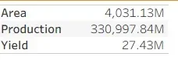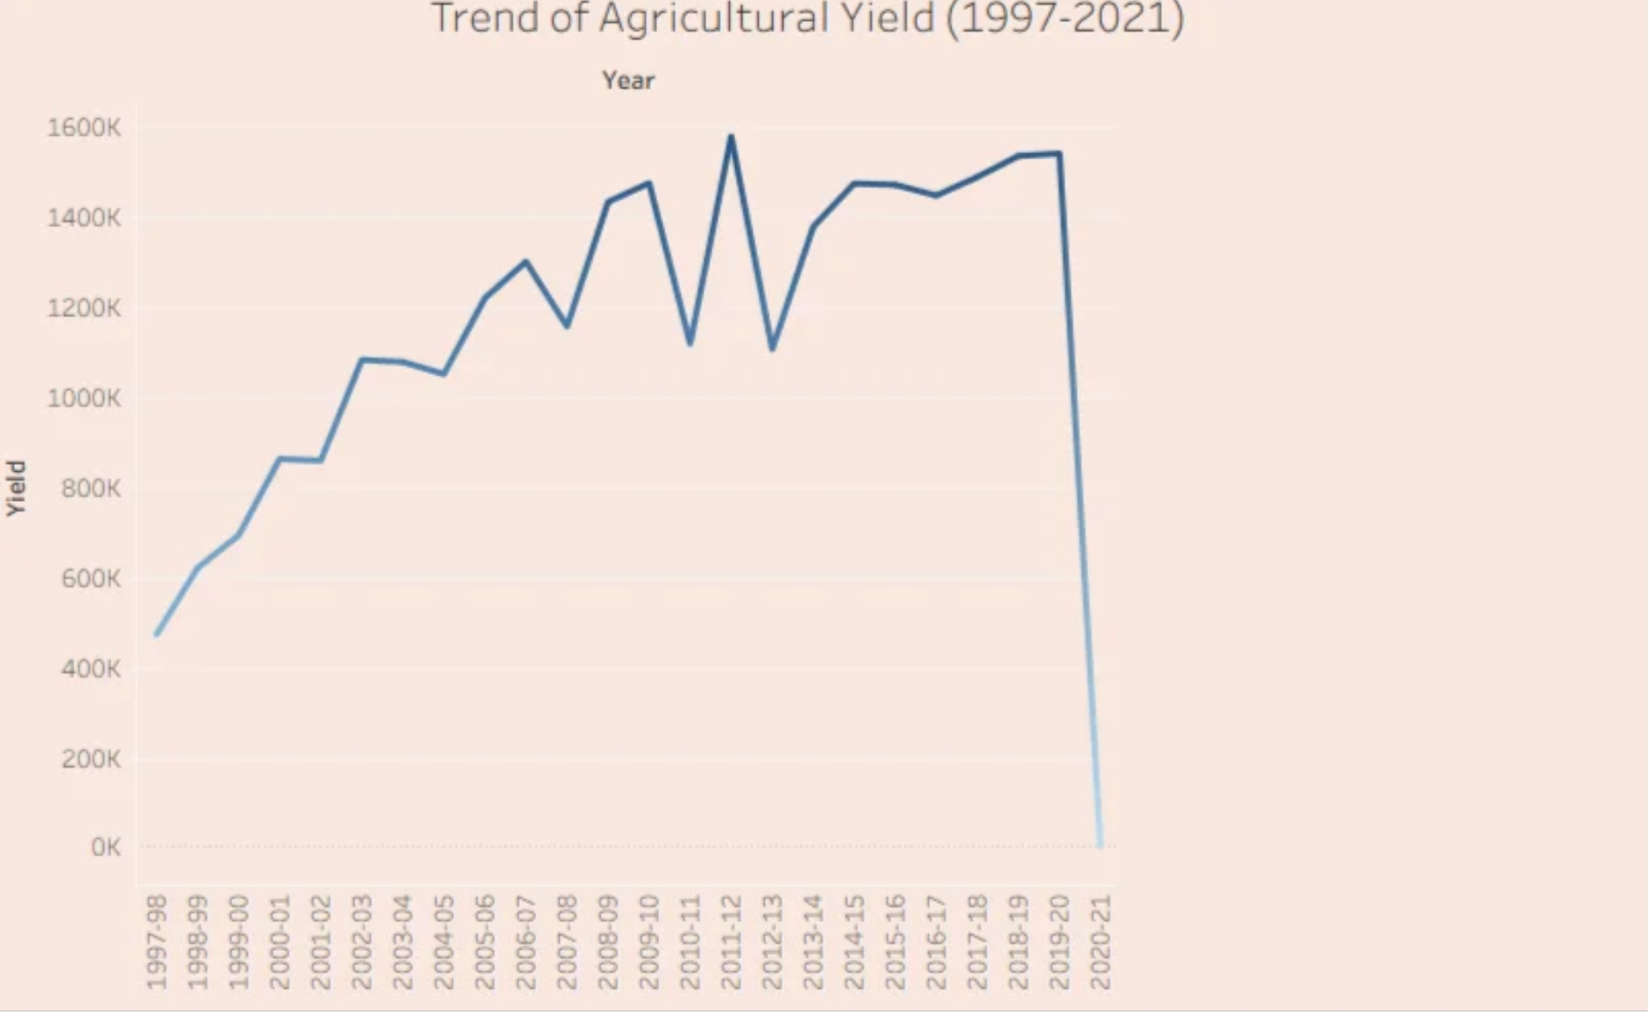
Save Pro essed Datathe the cleaned and processed use. | data for future
4. Data Visualization
4.1. Framing B usiness Questions
Q1. What is the trend of Agriculture Yield from 1997 to 2021?
Ans. In following visualization, line chart shows the trend of agriculture yield from 1997
to 2021.

Q2. What is total area and production of India’s Agriculture? Ans.

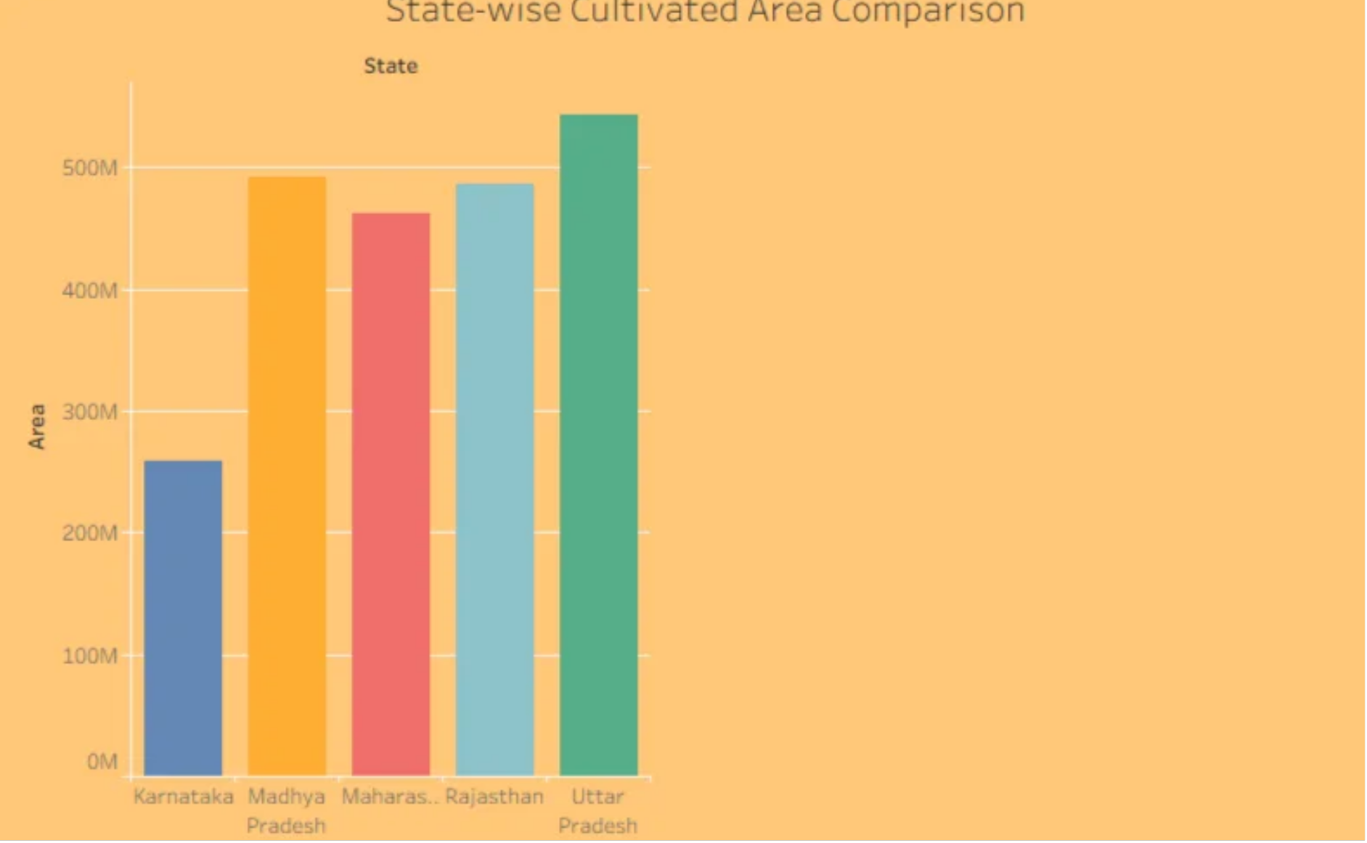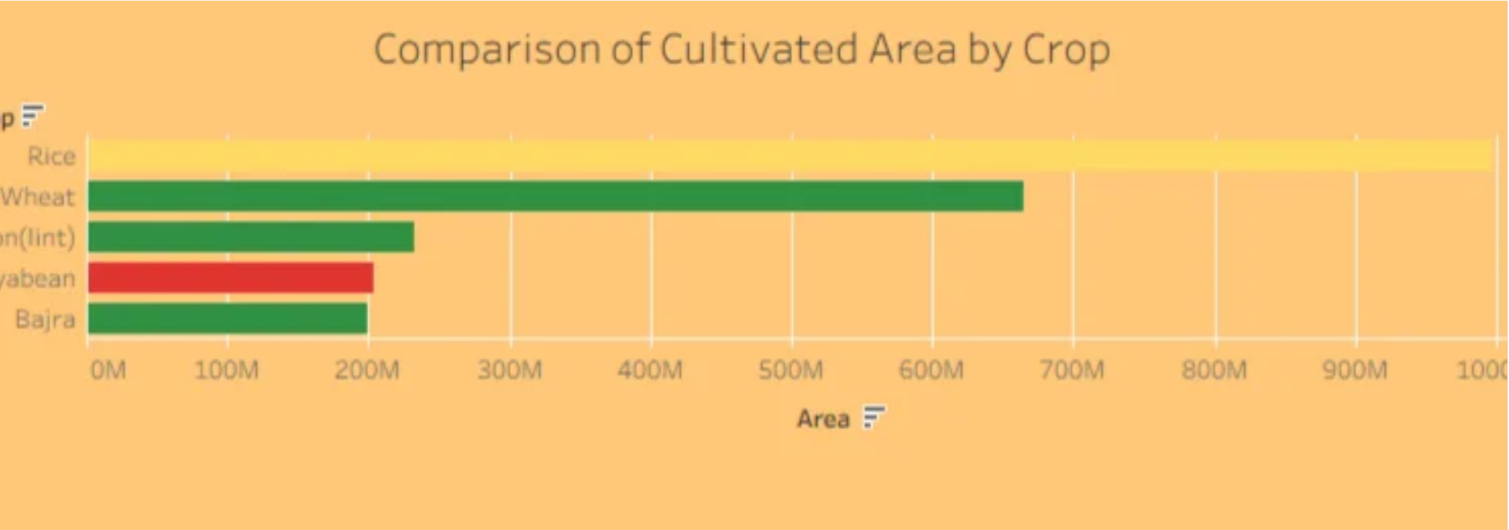Q3. Which crops have the highest cultivated area?
Ans. Rice has the highest cultivated area, followed by Wheat, cotton, soyabean and B ajra.

Q4. Which states have the highest cultivated area?
Ans. U ttar Pradesh has the highest cultivated area followed by Madhy Pradesh, Rajasthan, Maharashtra K arnatak and Andrapradesh.

Q5. Which states have the highest agricultural production?
Ans. K erala has the highest agricultural production followed by Tamil N adu, K arnataka, Andhra Prades and West B engal.

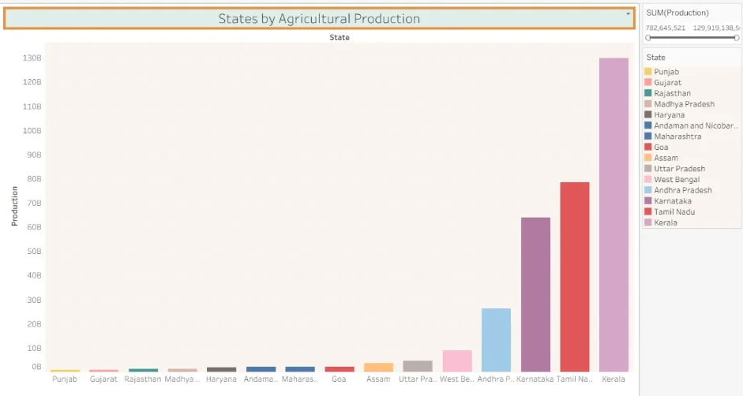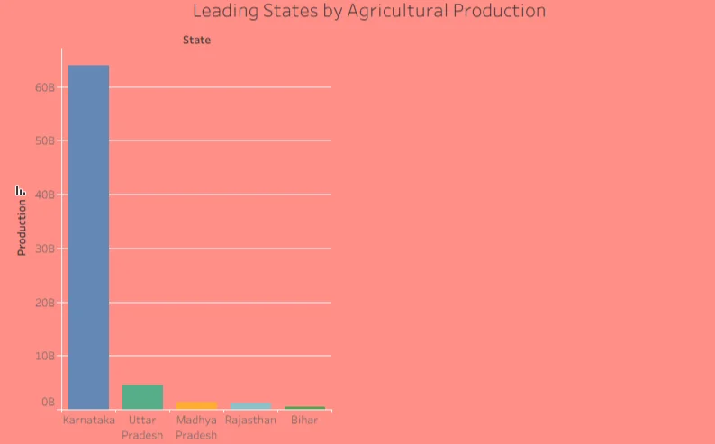

Q6. Which states have low agricultural production? Ans. These states have low agricultural production:-
Punjab, G ujarat, Rajasthan, Madhya Pradesh

Q7. What is year wise Total Agricultural production from 1997 to 2021?
Ans. Following bar graph shows year wise total agricultural production from 1997 to 2021: -

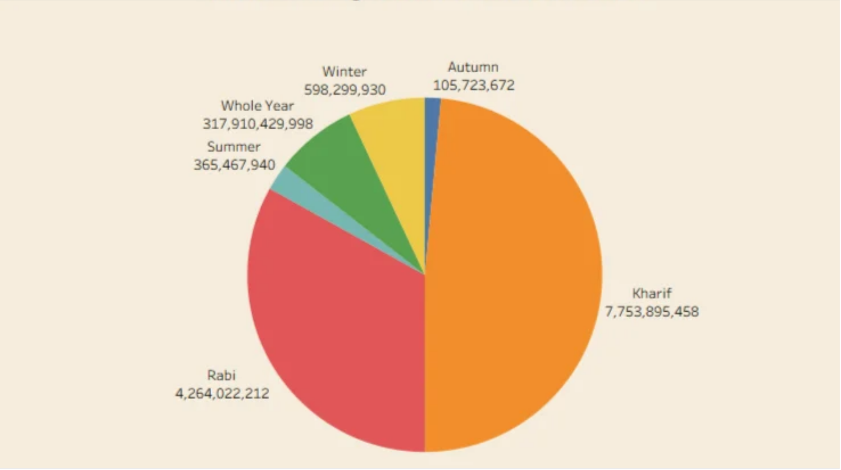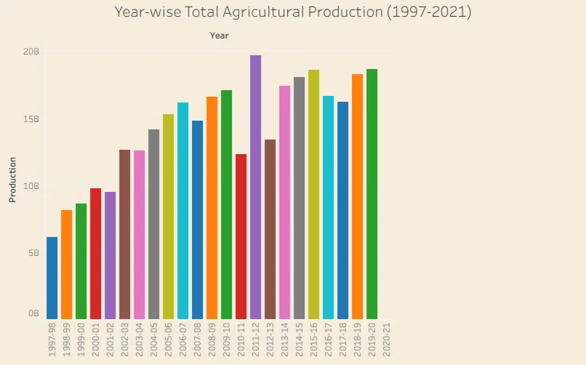

Q8. What is the season–wise Agricultural Production share?
Ans. Following pie chart shows season- wise Agricultural production share: -

Q9. What is the production of Potato during the season of kharif and rabi ?
Ans. The production of potato during the season of kharif and rabi is 204, 606, 567 tonnes. Following ma shows the states which produce potato during these seasons: -

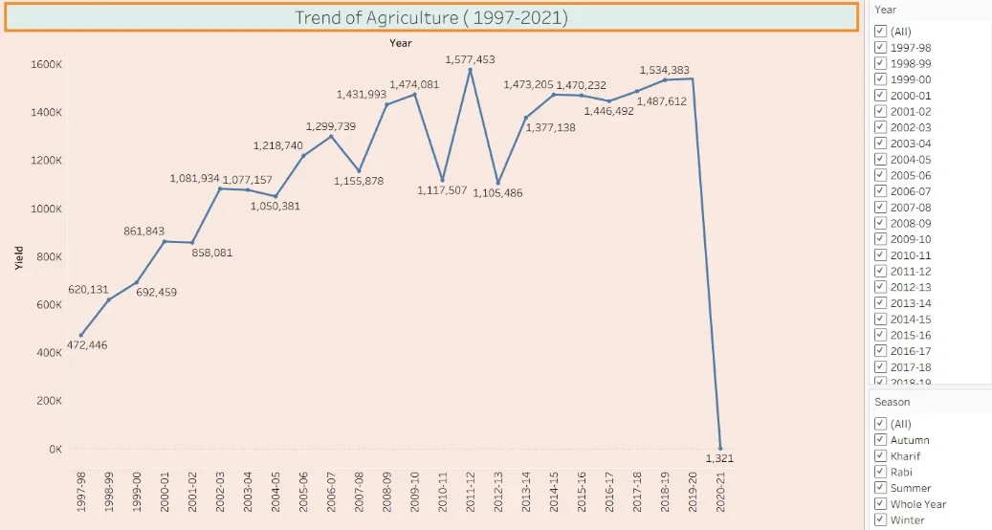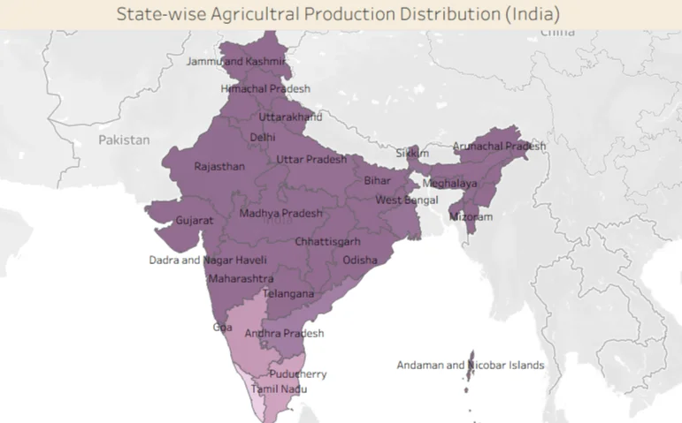

4.2. Developing Visualizations
1. Performance Summary

2. Trend of Agriculture from 1997 to 2021

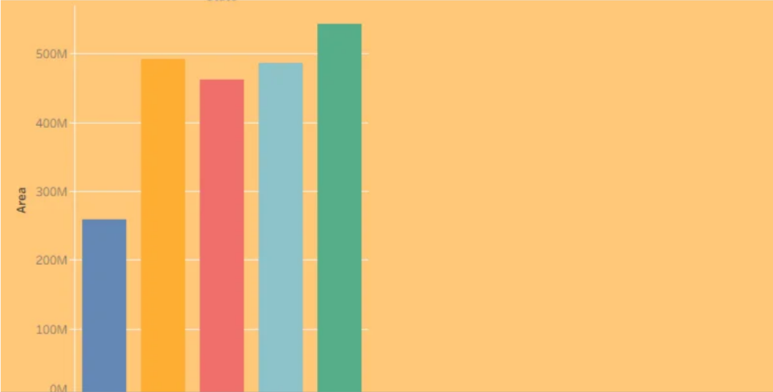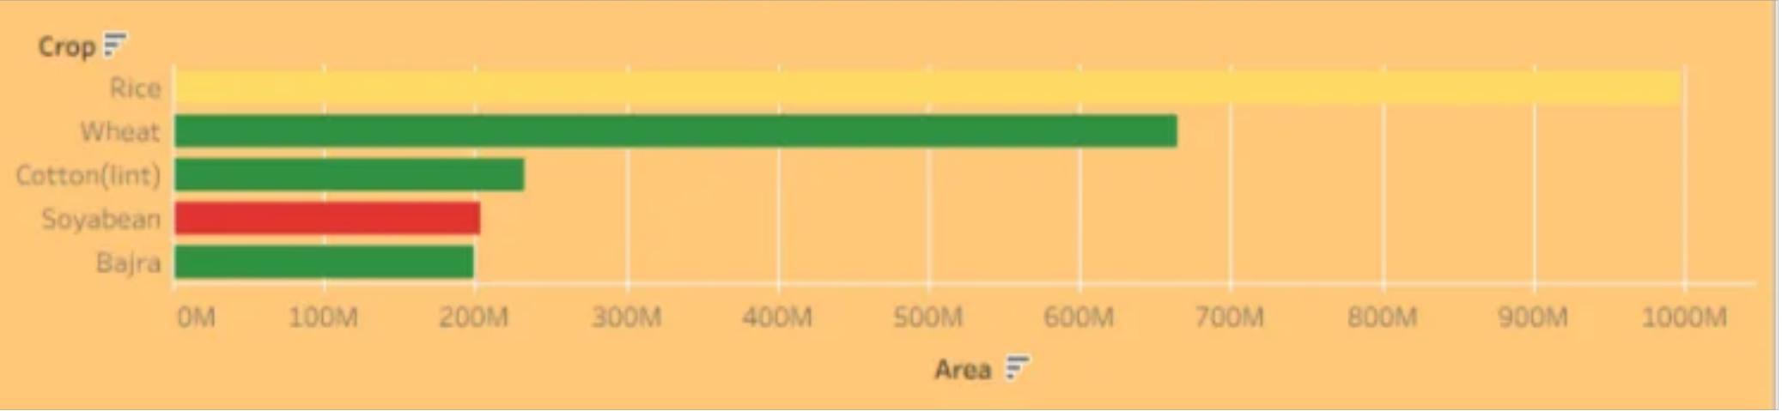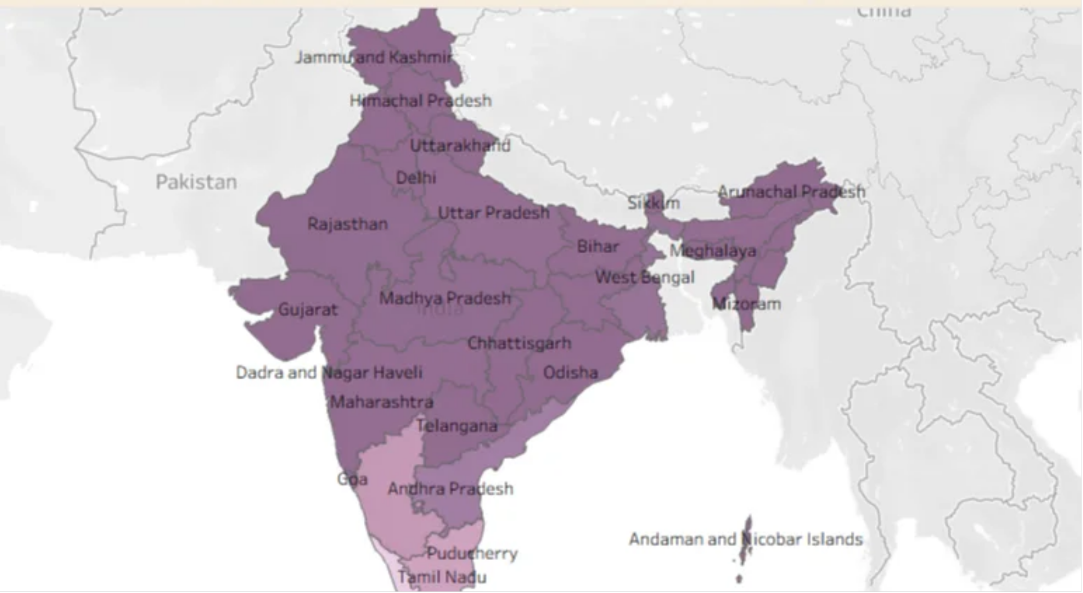3. State- wise Agricultural Production Distribution

4. Comparison of Cultivated Area by crop

5. State- wise cultivated Area comparison

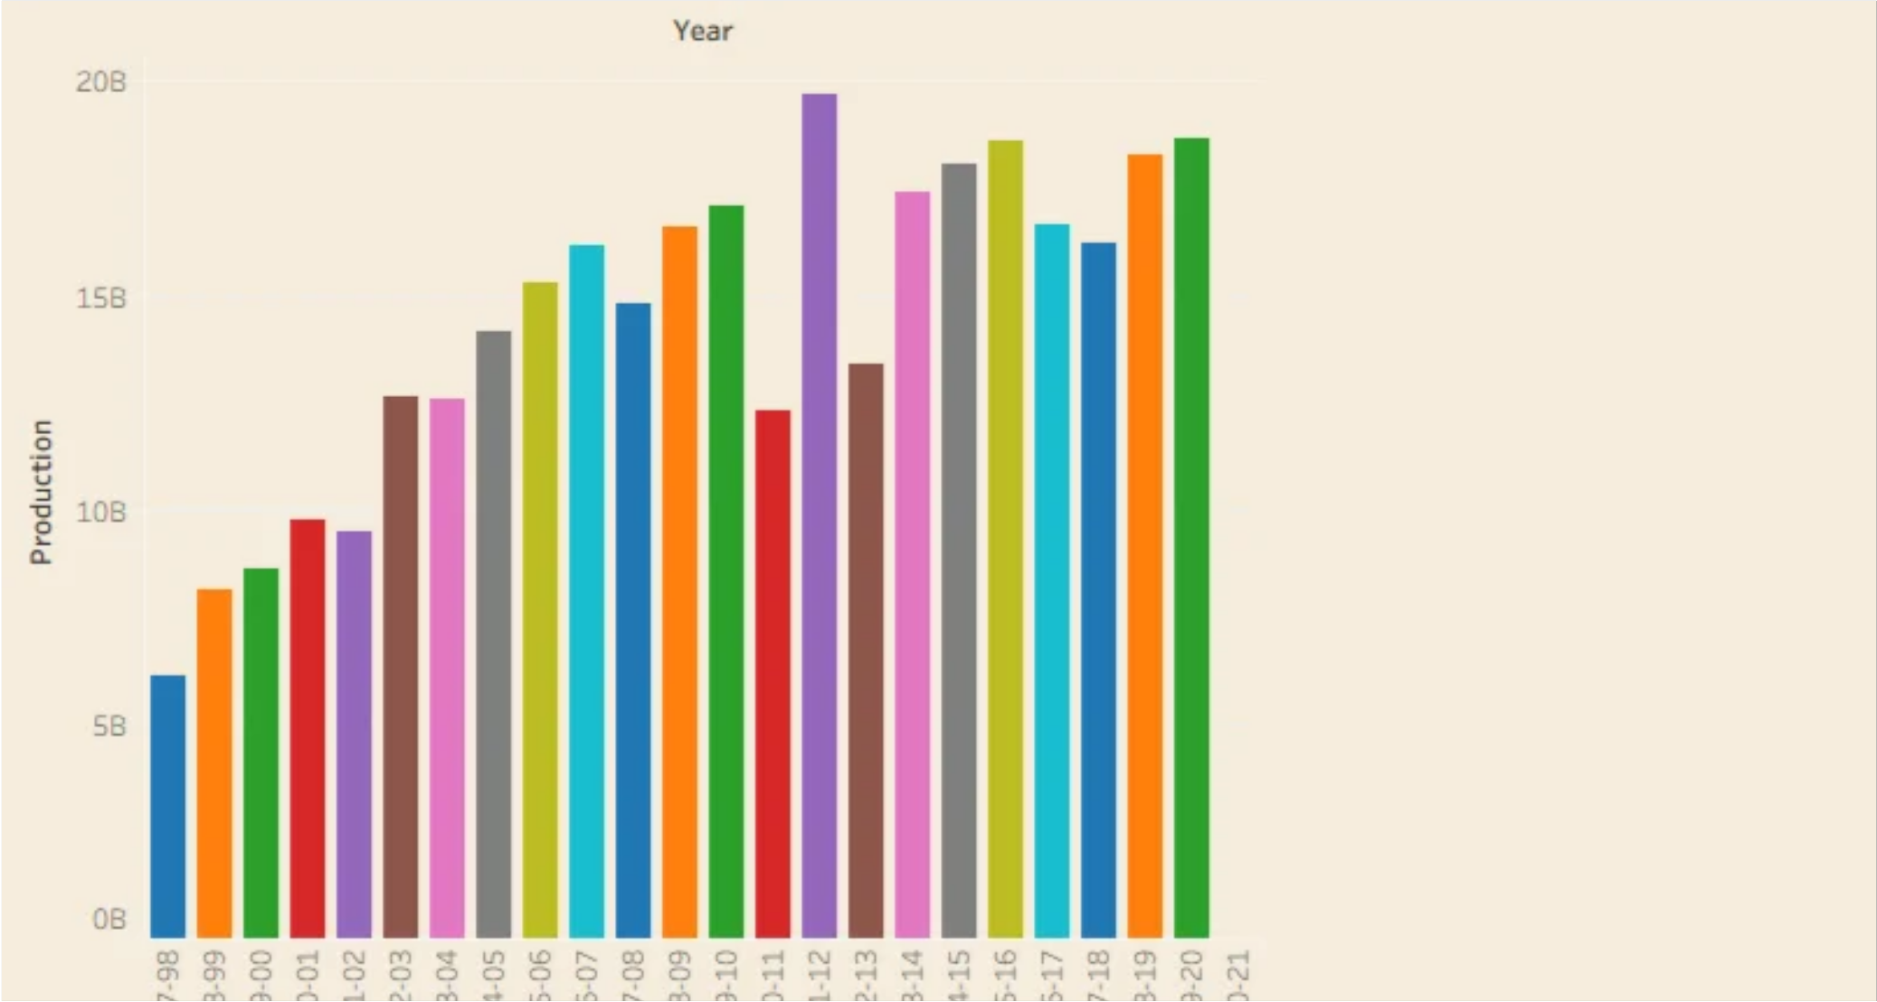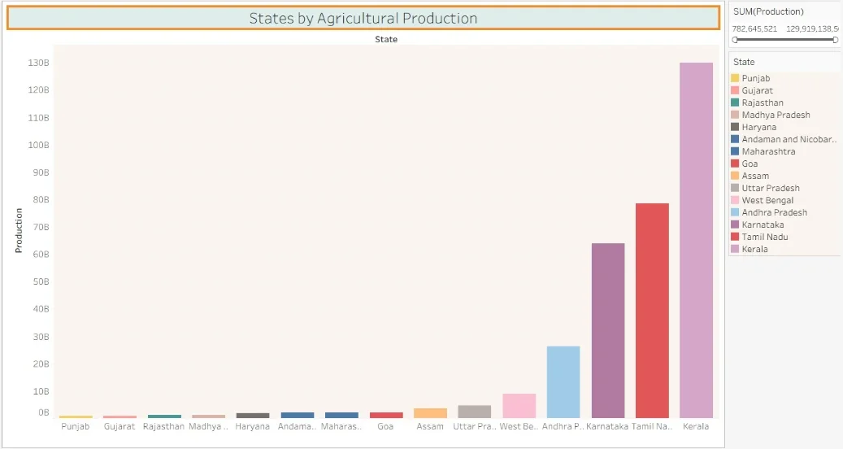6. States by Agricultural Production

7. Year wise total Agricultural Production

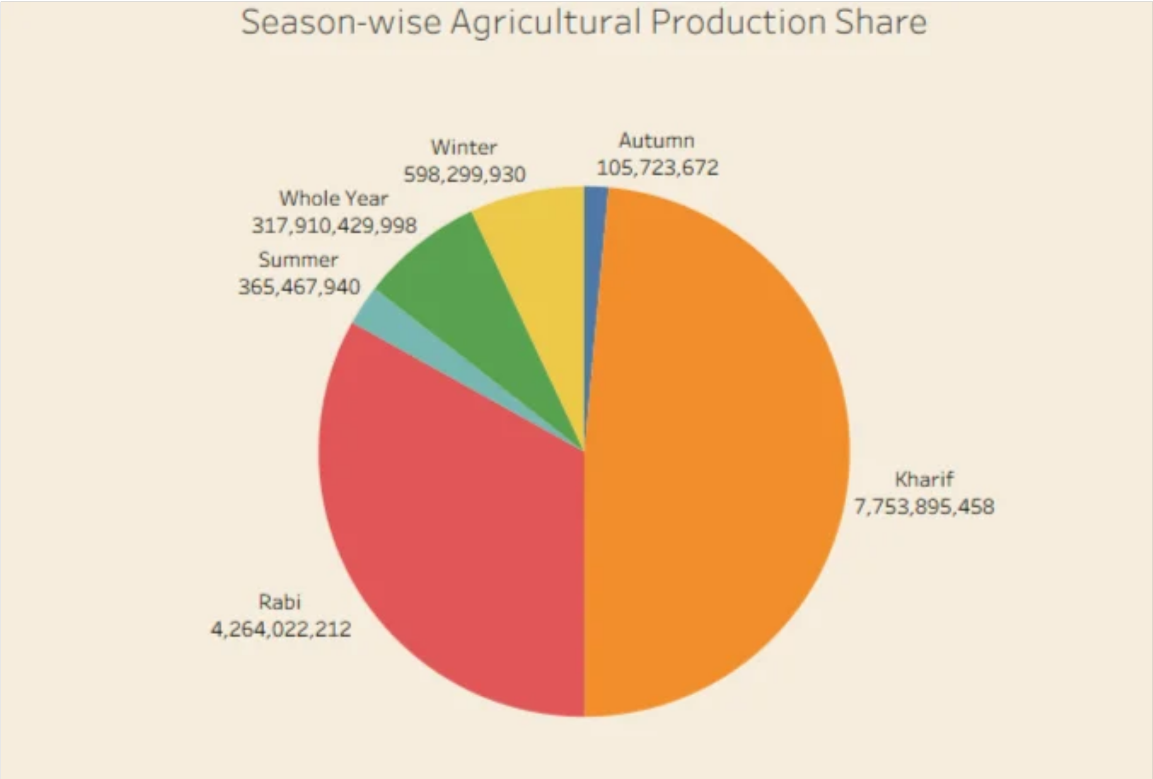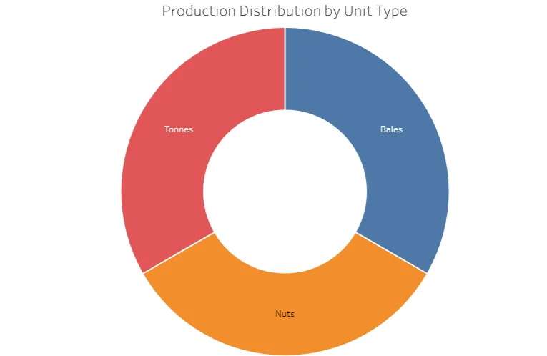8. Production Distribution by U nit Type

9. Season- wise agricultural production share

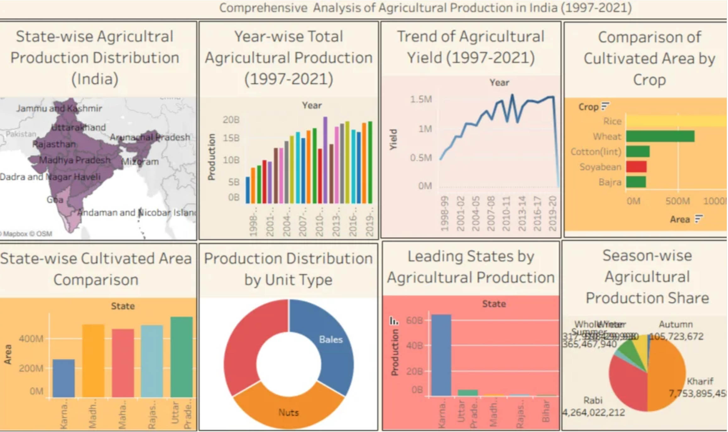5. Dashboard
5.1. Dashboard Design File
Activity 1: Interactive and visually appealing dashboards

Here are potential outcomes from the dashboard image provided: -
India’s Agriculture performance summary: - Total area
=4031.13Million HectareTotal production=330,997.84 Million tonnesTotal yield= 27.43 million tonnes Leading states by Agricultural production: - KeralaTamil Nadu Karnataka States with low production: - PunjabGujrat Rajasthan

• Cultivated area by crops: -
Rice has highest cultivated area followed by wheat, cotton, soyabean and bajra

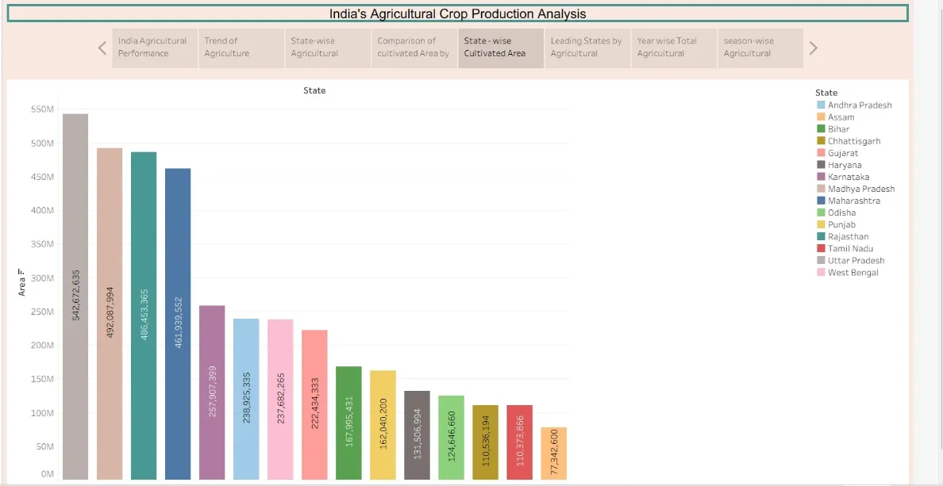• Trend of agriculture from 1997 to 2021
○ As shown in line graph India’s agriculture yield increase from 1997 to 2019 but suddenly goes
• down in 2020 Season- wise agriculture production share
Kharif has highest share followed by Rabi i.e. Kharif and Rabi are the season in which
production is highest in a year.

Activity 2
Publish Dashboard on Tableau Public and Paste the Dashboard Public link below:
https://public.tableau.com/views/Book1_17878260642250/ ComprehensiveAnalysisofAgriculturalProductioninIndia1997-2021?:language=en-US&:
sid=&:redirect=auth&:display_count=n&:origin=viz_share_link

6. Report
6.1. Story Design File

Observations:
• Yearly trend of agriculture production from 1997 to 2021.
• Leading states by production
• States with low production
• Seasonal production variations

• Comparison of States by cultivated area
• Total area of production and yield

Activity 2:
Publish Story on Tableau Public and Paste Public link below
hhttps://public.tableau.com/views/Book1_17878260642250/Story1?:language=en-US&:sid=&:redirect=auth&:
display_count=n&:origin=viz_share_link

7. Performance Testing
7.1 U tilization of Data filters
Data filters are used in visualizations to see the re q uired visualization. 7.2 N o of Visualization - 9
8. Conclusion/Observation
In conclusion, India’s agricultural crop production is an important part of the country’s economy and plays a major role in providing food and employment to a large population. The analysis shows that Indi produces a wide range of crops, such as rice, wheat, pulses, sugarcane, cotton, oilseeds, and various
horticultural crops. States that have high cultivated area but don’t produce crops accordingly. Wheat and Rice are two major crops in India.
9. Future Scope
The future of crop production in India has significant potential for growth through the adoption of modern technology, sustainable farming practices, and better agricultural planning. Crop production analysis can play an important role in identifying production trends, improving resource utilization, and supporting farmers and policymakers in making better decisions.
10. Appendix
10.1 GitHub & Project Demo Link GitHub Link
https://github.com/yuvraj0002007/India-s-Agricultural-Crop-Production-Analysis Project demo link
https://drive.google.com/file/d/1g8ODvFoITqMNw9b9h5emXOSTBjgjTxTl/view?usp=drivesdk

